**Student Internship Report**

The internship is an integral part of your study at Nile University. It should provide you with real life experience in your field of interest. To fulfill the academic requirements of the internship you are required to submit an internship report following the specifications outlined in this guide. This report should be submitted no longer than a week after your internship and should be handed to NU training and internship supervisor.

An Internship Report must include an outline of the business of the company for which you worked, summarize the work you did, and discuss the specific outcomes you achieved. The report must demonstrate your ability to communicate what you have done in your internship and how it relates to your academic background. The report should be typed, written in a professional way and does not exceed 15 pages (single spaced, font: Times New Roman 12).

**Report Guide:**

1. **Cover Page:** Write a page that states the title of your report, the name and address of the company where you completed your internship, your name and the name of the school and program for which you are preparing the internship report.
2. **Executive Summary:** Summarize the activities you performed during the internship, the achieved outcomes and how they relate to your academic background. This should be written after you finalize your report.
3. **The Company:** Describe the company and the specific department where you performed your internship.
4. **The Project:** Give more details on your job assignments/responsibilities, the knowledge/skills you gained from this experience, the challenges you faced, the connection you made between the hands-on learning during the internship with the theoretical concepts of your course of study, etc
5. **Conclusion:** Conclude with a summary on your experience, observations, recommendations and suggestions for improvement.

**Note: Please consider the above a guideline. Feel free to support your report in any way you like; a video, photographs, an interview, etc and submit such materials as appendix to your report.**



**Student Internship Report Cover Page**

**Initial Report** **Date: 9/12/2022**

Name of Intern: Hadeer Khaled Khalifa NU ID: 1410199

School: MENG Program:Mechatronics

Company/Organization offering Internship: Innovation Hub

Address: 6th October Phone:

Name of Supervisor: Title:

Supervisor Phone: Supervisor e-mail:

Internship Duration: From: 15 /7 To: 15/9

**Job Responsibilities:**

* Using 3D printers and solid work for designing
* Designing PCB
* ANSYS analysis for the turtle flippers

**Expected Outcomes:**

* Understanding the concept of slicing of 3D model
* Knowing how to use 3D printers
* The manufacturing process of PCB
* Design different models of air pillows
* Using ANSYS to see the actuation and total deformation of air pillows

Hadeer Khaled ___________________ ____________________________

Student Signature Supervisor Signature Program/Center Director Signature



**INNOV_2022_01 Internship Report**

Name: Hadeer Khaled

ID: 1410199

Mechatronics Engineering

Program: MENG

Table of Content:

Executive summary: 5

The outcome: 5

Introduction: 5

Trails of turtle flippers actuations: 6

Trail 1: 6

Trail 2: 7

Trail 3: 7

7

Conclusion: 7

References: 8

8

8

# Executive summary:

The internship was working on turtle air pillow Design for turtle flipper. The internship consisted of two parts:

* Using 3D printers and solid work for designing
* Designing PCB
* ANSYS analysis for the turtle flippers

## The outcome:

* Understanding the concept of slicing of 3D model
* Knowing how to use 3D printers
* The manufacturing process of PCB
* Design different models of air pillows
* Using ANSYS to see the actuation and total deformation of air pillows

# Introduction:

Soft robotics has opened the world to a special generation of robots that have assisted researchers in solving issues that rigid systems are unable to handle. Because of their gentle nature, they are safe to interact with humans, eliminating the risk of harm during operation. Other advantages they have over their rigid counterparts include their ease of adjusting to the environment, picking and placing delicate objects without damaging them, and flexibility to operate in complex environments. This new field is demonstrating these benefits in a variety of applications, including biomedical and industrial, particularly through the development of soft manipulators and grippers. Here the work was focused on improving the design of air pillows of turtle flippers using CAD for design and ANASYS for simulation. [1]

At first, we start with the design process, its target is producing a design of turtle flippers which we want to analyze preparing a superior design in Solid Works, and then we fixed all errors that might exist in the design such as missing faces, overlapping faces and angels. After finishing the design and fixing all the errors, we need to export the design to an extension that is readable by ANSYS, STEP (Standard for the Exchange of Product Data) or OBJ file extensions are easily readable by ANSYS. Next was the material selection which turtle flippers materials are TBU Following CAD modeling, Ansys, finite element analysis software, was used to predict its behavior.[2]

# Trails of turtle flippers actuations:

After designing the flippers, it is the start of ANSYS work which is the Static Structural analysis type and gives it some initial parameters. Then, by providing a material constant, we established the TPU material Ogden 3rd Order model. In simulation step, In the meshing module, generate mesh was used to provide initial grid mesh. To enhance the bad grid around the turtle flippers, many mesh settings are used to provide more accurate results and depiction of the analysis of turtle flippers with size of element is 0.5m. The boundary conditions are: The fixed support on the one of end Face of the Finger gripper, Pressure of 3-1.5 bar into the channels on inner walls, Standard earth gravity of 9.806 m/s2 acts in Z direction. The results were to find the actuation and total deformation.

## Trail 1:

The first trail was a poor success due to unrealistic dimensions and the thickness of the shell was more than o.5mm. Moreover, usually the work of actuation was using 3 bar and the goal was to reduce the pressure to 1.5 bar . Therefore, the design was a failure because it was not actuated in 1.5 bar.

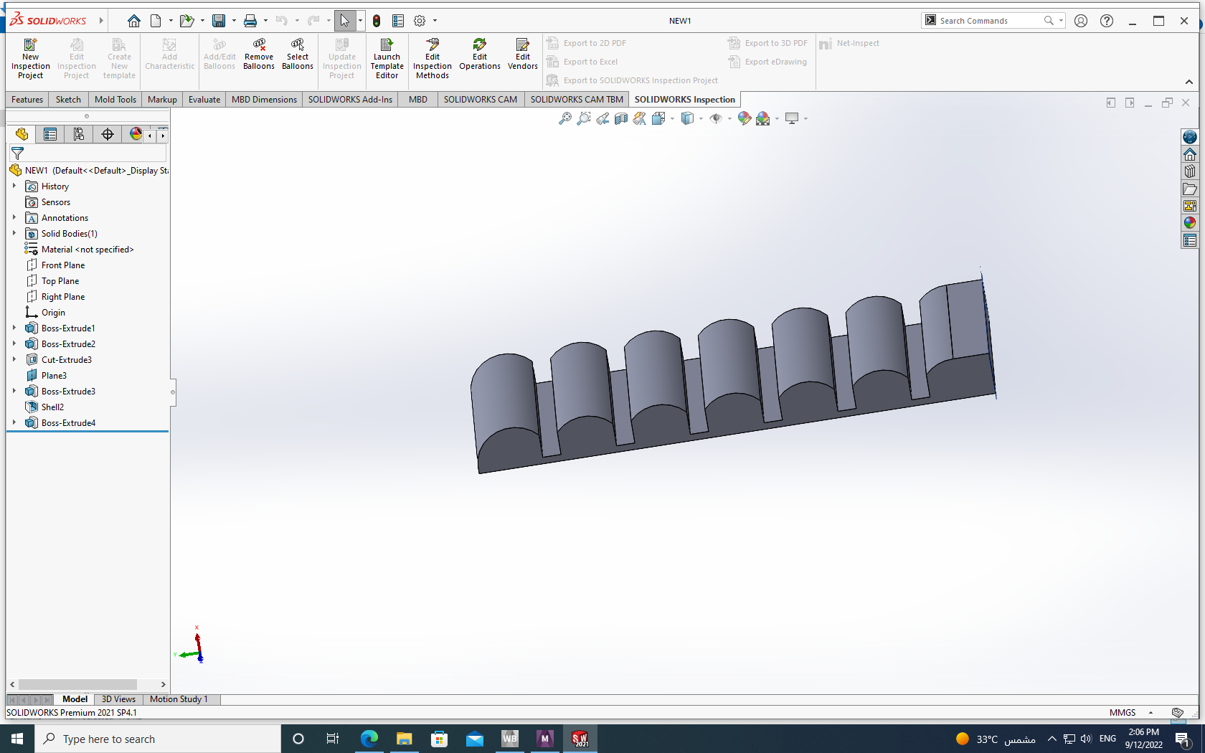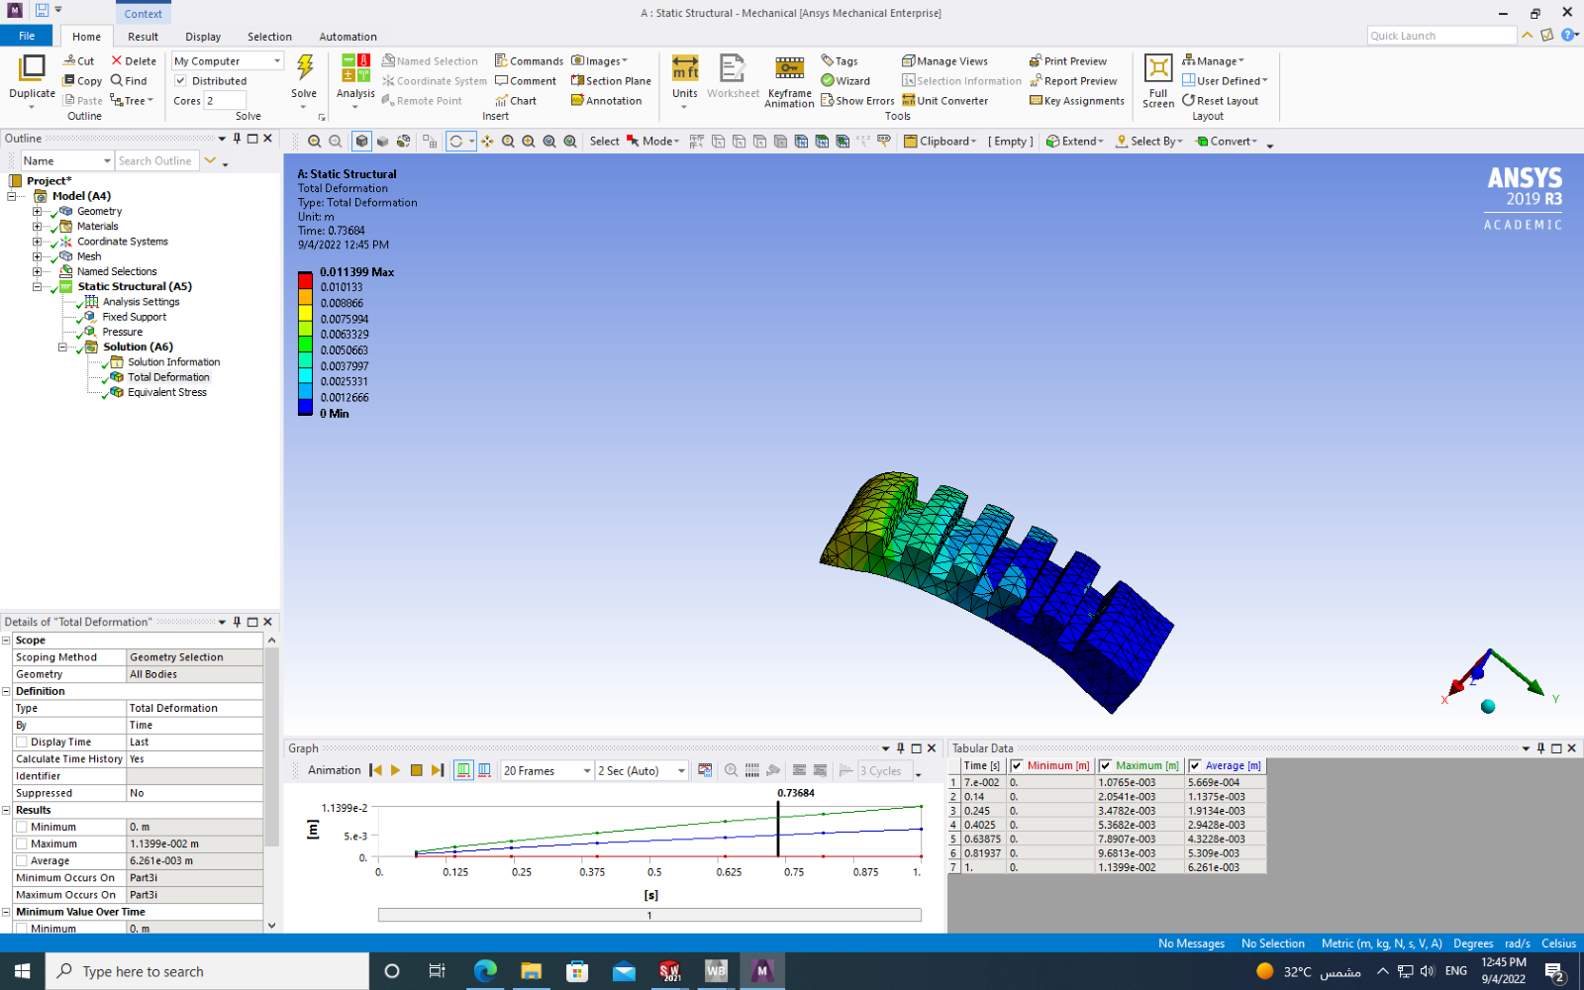

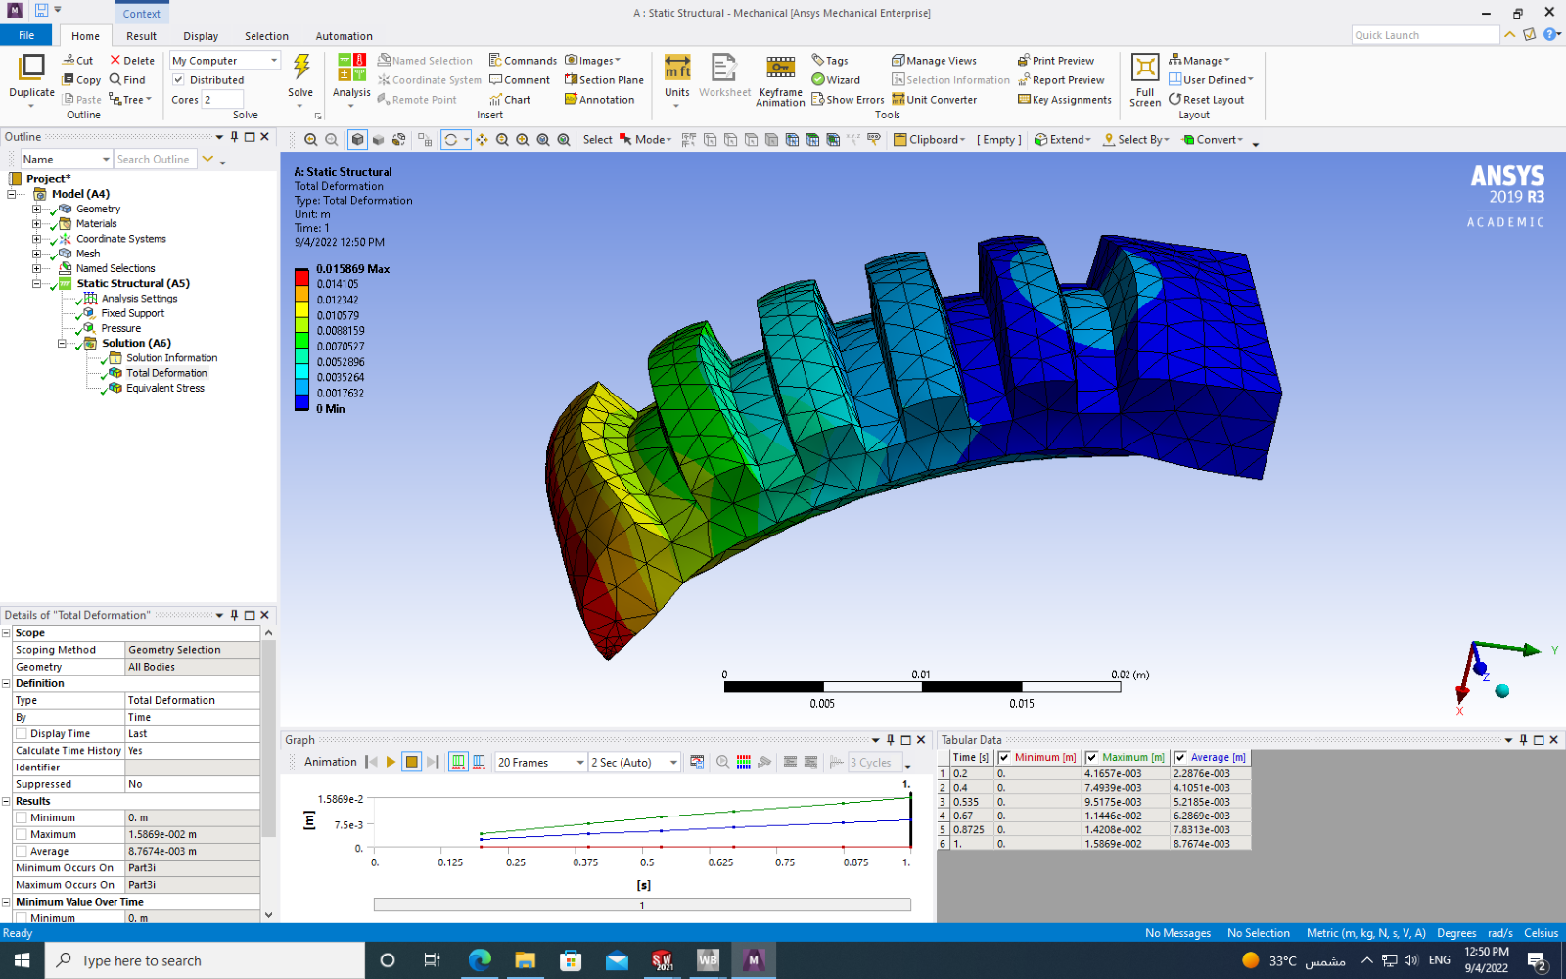

## Trail 2:

In this design, there was support inside the air pillow to control more the flow of the air . Moreover, the thickness of the shell was reduced to o.5mm. However, the actuation was not as expected.

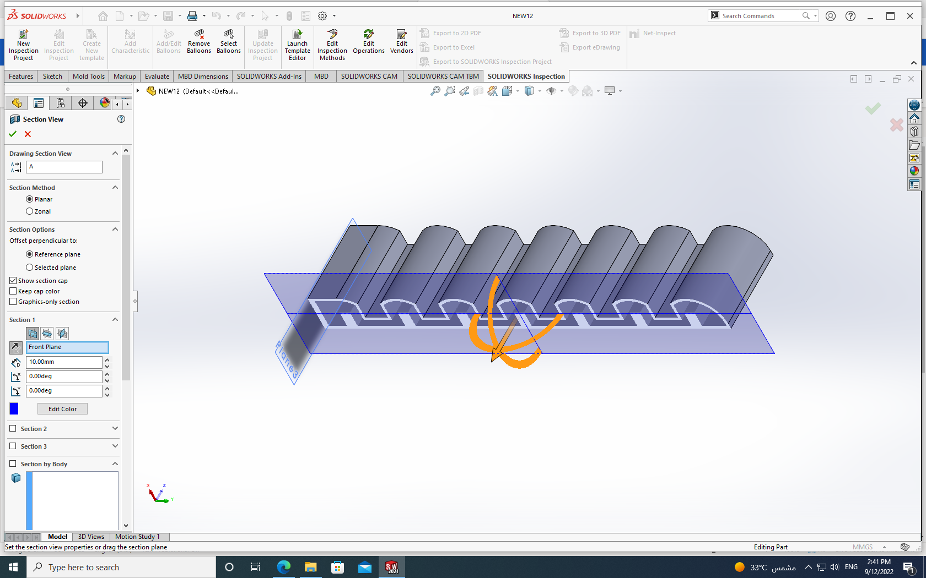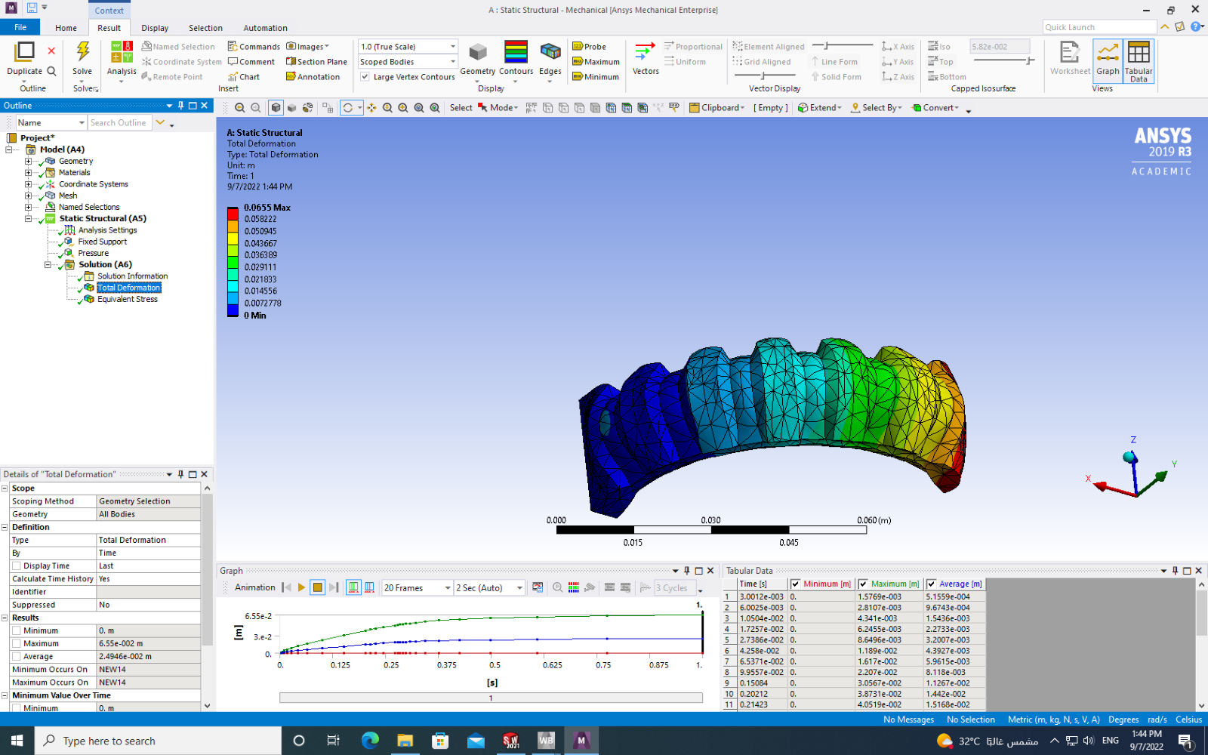

## Trail 3:

In this design, the edit was in support for better air flow however, there was failure in the results of stress and total deformation.

## 

# Conclusion:

The design affects the actuation of the turtle front leg. Although there are some designs that give better actuation. However, the design is a failure due to results of total deformation and total stress. As result of many designs, only unchangeable result to get the closest actuation of air area under the air pillow should have small height compared to air pillow height.

# References:

[1] Zhou, X., Majidi, C., & O’Reilly, O. M. (2015). Soft hands: An analysis of some gripping mechanisms in soft robot design. International Journal of Solids and Structures, 64, 155-165.

[2] Zaidi, S., Maselli, M., Laschi, C., & Cianchetti, M. (2021). Actuation technologies for soft robot grippers and manipulators: A review. Current Robotics Reports, 2(3), 355-369.

# 

## 